SAVEETHA SCHOOL OF ENGINEERING (SIMATS)
Department of Computer Science and Engineering
Programme: Bachelor of Engineering (BE)
Specialization: Artificial Intelligence and Data Science
Course Code & Name: DSA06 - Data Handling and Visualization
ASSIGNMENT REPORT
Retail Sales and Customer Behaviour Data Visualization and Analytics System
Student Name | RISHI.B.E, MAHESH KUMAR.K, PAWAN KALYAN.R
Register Number | 192424044, 192424253,192424116
Academic Year / Batch | 3rd year/ 2024
Faculty / Course Instructor | LOGANAYAGI.S
Assignment Title | Retail Sales and Customer Behaviour Data Visualization and Analytics System
Date of Issue | 01.09.2026
Date of Submission | 01.09.2026
Maximum Marks | 100

Table of Contents
Table of Contents 1
1. Assignment Problem / Challenge 1
2. Problem Statement 1
3. Requirements and Constraints 1
3.1 Functional Requirements 1
3.2 Technical Constraints 1
3.3 Performance and Reliability Constraints 1
3.4 Data Integrity and Professional Considerations 1
4. Student Work & Assessment Components 1
5. Solution / Design / Methodology 1
5.1 Data Handling and Visualization Fundamentals (CO1) 1
Variable Type Classification 1
Aesthetic Mappings, Scales and Colour 1
5.2 Amount Visualization (CO2) 1
Comparison and Justification 1
5.3 Distribution Analysis (CO2) 1
Comparison and Justification 1
5.4 Proportion Visualization (CO2) 1
Comparison and Justification 1
5.5 Relationship and Association Analysis (CO3) 1
Interpretation Summary 1
5.6 Correlation Analysis (CO3) 1
5.7 Dimensionality Reduction (CO3) 1
Principal Component Analysis (PCA) 1
t-SNE 1
Comparison: PCA vs t-SNE 1
5.8 Overall Solution Workflow 1
6. Results, Testing and Validation 1
7. Performance Analysis 1
8. Analysis, Trade-offs and Justification 1
8.1 Visualization Selection 1
8.2 Distribution Visualization 1
8.3 Proportion Visualization 1
8.4 Relationship and Dimensionality Analysis 1
8.5 Final Recommendation 1
9. Broader Considerations / Professional Responsibility 1
10. Conclusion 1
11. Student Reflection 1
1. What was learned beyond the classroom 1
2. Most challenging visualization technique and why 1
3. A specific problem faced selecting a visualization and how it was solved 1
4. How understanding of data types influenced visualization choices 1
5. Which visualization gave the most useful insight, and why 1
6. How dimensionality reduction changed understanding of multivariate data 1
7. What would be improved with more time or resources 1
12. References 1
Appendix: Full Python Source Code 1
A.1 Dataset Generation 1
A.2 Visualization and Analysis Pipeline 1
A.3 Workflow Diagram Generation 1

1. Assignment Problem / Challenge
A mid-sized retail organization operates through a network of physical stores and an online platform, generating large volumes of transactional data every day: product sales, quantities purchased, discounts applied, customer ratings, regional performance, and customer segment behaviour. The management and analytics teams face a recurring difficulty in making sense of this data. The datasets are large and multi-dimensional, and without a structured visualization approach, it becomes hard to identify which chart type is appropriate for a given question, to understand the magnitude and spread of sales amounts across categories, to compare proportions of revenue contributed by different categories or regions, to detect relationships between variables such as discount and sales value, and to interpret patterns hidden in many correlated variables at once.
Choosing an inappropriate visualization technique - for example, a pie chart for a variable with many categories, or a bar chart for continuous distribution data - leads to misleading or unclear conclusions. Similarly, when many numerical variables interact (price, quantity, discount, rating, frequency), two-dimensional charts alone cannot reveal the overall structure of the data, and a dimensionality-reduction approach is needed to visualize the multivariate relationships in a reduced space.
The central, higher-order challenge addressed in this assignment is therefore to design, implement, evaluate, and justify a complete visualization and analytics system for retail sales and customer behaviour data. The system must demonstrate a sound understanding of visualization fundamentals (visual mappings, scales, coordinate systems, and colour), must correctly visualize amounts, distributions, and proportions, must analyze relationships and correlation between variables, must apply dimensionality reduction (PCA together with t-SNE) to multivariate data, and must compare alternative techniques with evidence-based justification of the design choices made at every stage.

2. Problem Statement
The assignment is decomposed into eight modules, summarized in Table 1 below.
# | Module | Key Requirement
1 | Data Handling & Visualization Fundamentals | Load and inspect the dataset; identify variable types; explain aesthetic mappings, scales, coordinate systems and colour choices.
2 | Amount Visualization | Visualize magnitudes (sales, quantity) using at least 3 techniques (bar, grouped/stacked bar, heatmap) and compare them.
3 | Distribution Analysis | Analyze the spread, skewness and outliers of numerical variables using at least 4 techniques (histogram, KDE, boxplot, violin, ECDF, Q-Q).
4 | Proportion Visualization | Show part-to-whole relationships using at least 2 techniques (pie, stacked bar) and justify the clearer one.
5 | Relationship Analysis | Examine associations between variable pairs using at least 3 techniques (scatter, bubble, hexbin).
6 | Correlation Analysis | Compute and visualize the Pearson correlation matrix; identify strong and weak relationships.
7 | Dimensionality Reduction | Apply PCA (mandatory) and t-SNE (mandatory) on standardized numerical features and compare the two embeddings.
8 | Visualization Comparison & Interpretation | Compare alternative chart types for the same data and justify the clearest, evidence-based choice.

Table 1: Problem statement modules

3. Requirements and Constraints

3.1 Functional Requirements
- Load the retail sales and customer behaviour dataset using pandas and display its structure.
- Inspect the dataset for shape, data types, missing values and summary statistics.
- Identify and classify variables as numerical, categorical, discrete or continuous.
- Select appropriate visual aesthetics (position, colour, size, shape) for each analysis.
- Generate amount-based visualizations for sales and quantity comparisons.
- Generate distribution visualizations to study spread, skewness and outliers.
- Generate proportion visualizations to show category and region contribution.
- Generate relationship visualizations to study associations between numerical variables.
- Compute and visualize a Pearson correlation matrix across numerical variables.
- Apply PCA for dimensionality reduction and report explained variance.
- Apply t-SNE for non-linear dimensionality reduction and compare with PCA.
- Compare alternative visualization techniques for the same analysis and justify the preferred one.
- Draw evidence-based conclusions from the generated visualizations.

3.2 Technical Constraints
- Implementation language: Python 3.x.
- Libraries used: pandas, numpy, matplotlib, seaborn, scipy, scikit-learn (StandardScaler, PCA, TSNE).
- Every chart must carry a descriptive title, labeled axes, and a legend where more than one series/category is shown.
- PCA is mandatory for dimensionality reduction; t-SNE (or UMAP) is mandatory as the second, non-linear technique - this report uses t-SNE.
- The dataset, its source, and its variable dictionary must be documented before any analysis.

3.3 Performance and Reliability Constraints
- All results must be reproducible: a fixed random seed (42) is used throughout for data generation, sampling, PCA and t-SNE.
- Missing data (2% of Discount and CustomerRating fields, injected deliberately to simulate real-world data quality issues) is handled by median imputation, and the imputation strategy is documented.
- All algorithm parameters (e.g., t-SNE perplexity = 30, PCA components) are explicitly stated so the analysis can be repeated.

3.4 Data Integrity and Professional Considerations
- The dataset source and generation method are disclosed transparently in Section 1 of the Solution (Data Handling).
- No chart axis, scale or aggregation is manipulated to exaggerate or understate a pattern; all axes start at zero unless a Q-Q or scatter plot requires otherwise.
- No individual customer identifiers or personally identifiable information (PII) are present in or exposed by the dataset; only OrderID (a synthetic order reference) is used as a row identifier.
- All interpretations in Sections 5 and 8 are grounded in the actual computed statistics and generated figures, not assumptions.

4. Student Work & Assessment Components
Component | Marks | Expected Evidence
Problem Understanding | 10 | Clear restatement of the industry case and central challenge (Section 1).
Application of Course Knowledge | 20 | Correct use of visual mappings, scales, distributions, proportions and relationships (Sections 5.1-5.6).
Solution / Design / Methodology | 20 | End-to-end Python methodology from data loading to dimensionality reduction (Section 5).
Modern Tools & Techniques | 10 | Use of pandas, seaborn, scikit-learn, PCA and t-SNE (Sections 5.7, Appendix).
Results, Testing & Validation | 15 | Test case table and screenshots of key outputs (Section 6).
Analysis, Trade-offs & Justification | 15 | Comparative justification of techniques (Section 8).
Broader Considerations | 5 | Data integrity, privacy and responsible analysis discussion (Section 9).
Documentation & Reflection | 5 | Well-structured report, references and reflection answers (Sections 11-12).

5. Solution / Design / Methodology

5.1 Data Handling and Visualization Fundamentals (CO1)
A synthetic retail sales and customer behaviour dataset of 1,500 transaction records and 12 variables was generated in Python using numpy's random generator with a fixed seed (42), modelled on the structure of public retail datasets such as the Kaggle "Superstore Dataset". The dataset was chosen to be synthetic (rather than downloaded) so that its distributions, category proportions and relationships could be controlled and fully documented, while remaining realistic in shape. It is saved as retail_data.csv and contains no personally identifiable customer information - only a synthetic OrderID is used as a row identifier.
Variable | Type | Description
OrderID | Categorical (nominal, identifier) | Synthetic unique order reference.
OrderDate | Datetime | Date the order was placed (Jan 2024 - Dec 2025).
ProductCategory | Categorical (nominal) | One of 8 product categories (Electronics, Furniture, Clothing, etc.).
ProductName | Categorical (nominal) | Specific product within a category.
Region | Categorical (nominal) | Sales region: North, South, East, West, Central.
CustomerSegment | Categorical (nominal) | Consumer, Corporate, or Home Office.
Quantity | Numerical (discrete) | Number of units purchased in the order.
UnitPrice | Numerical (continuous) | Price per unit in USD.
Discount | Numerical (continuous) | Discount fraction applied (0-0.5).
SalesAmount | Numerical (continuous) | Final sales value = Price x Quantity x (1-Discount).
CustomerRating | Numerical (continuous) | Customer satisfaction rating (1-5).
PurchaseFrequency | Numerical (discrete) | Number of prior purchases by the customer.

Dataset summary: 1500 records, 12 variables. Missing values were deliberately injected into 2% of the Discount and CustomerRating fields to simulate realistic data-quality issues, and were imputed using the column median before analysis (a robust, distribution-preserving strategy suitable for right-skewed numeric fields).

Variable Type Classification
Category | Variables
Numerical - Continuous | UnitPrice, Discount, SalesAmount, CustomerRating
Numerical - Discrete | Quantity, PurchaseFrequency
Categorical - Nominal | ProductCategory, ProductName, Region, CustomerSegment, OrderID
Datetime | OrderDate

Aesthetic Mappings, Scales and Colour
- Position: used as the primary encoding for magnitude and distribution (e.g., bar height in Figure 1, x-position of points in the scatterplot in Figure 12) because position along a common scale is the most accurately perceived visual channel.
- Colour: categorical (qualitative) colour palettes (seaborn "Set2") are used to distinguish nominal categories such as ProductCategory and CustomerSegment (Figures 1, 2, 17, 18); sequential palettes ("YlGnBu", "Blues", "viridis") are used for continuous magnitude in heatmaps and hexbin plots (Figures 3, 14); a diverging palette ("coolwarm") is used for the correlation matrix (Figure 15) since correlation values are signed and centred at zero.
- Size: used in the bubble chart (Figure 13) to encode CustomerRating as a third quantitative dimension alongside price and quantity.
- Shape: category membership is additionally distinguished by colour and legend rather than shape, since shape is a weaker channel for more than 4-5 categories; this dataset has 8 categories.
- Scales: linear scales are used for all monetary and count variables; the Q-Q plot (Figure 9) uses a theoretical-quantile scale to compare against a normal distribution.
- Coordinate systems: Cartesian coordinates are used throughout except the pie chart (Figure 10), which uses a polar/angular coordinate system suited to whole-to-part comparison of a small number of categories.

5.2 Amount Visualization (CO2)
Three techniques were implemented for amount-based analysis: a bar chart, a grouped bar chart, and a heatmap.
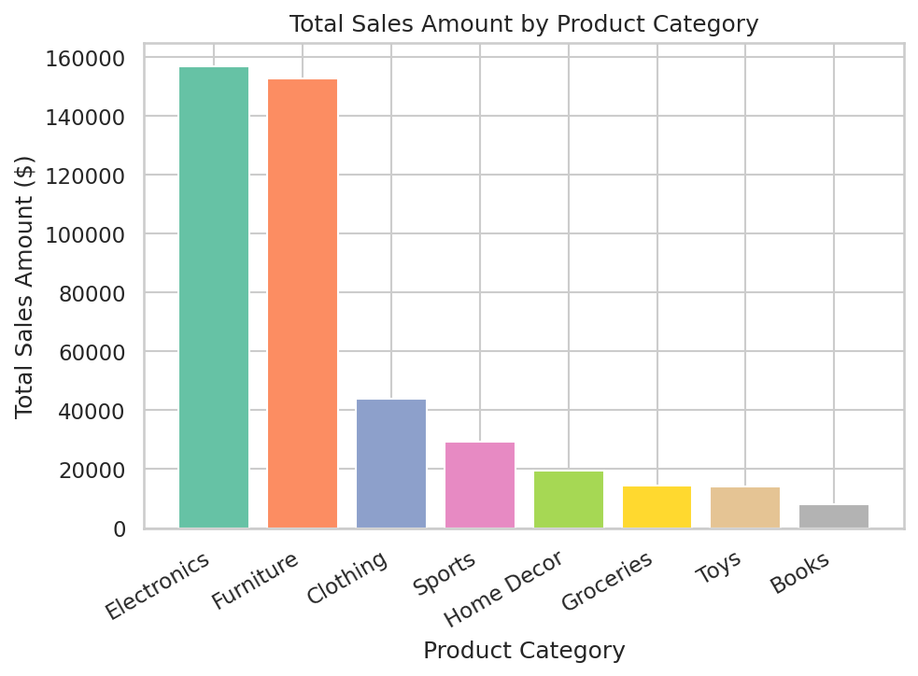
Figure 1: Total sales amount by product category (Bar Chart)
Electronics and Furniture contribute the largest total sales amounts, while Books and Toys contribute the least, reflecting both category popularity (sample proportions) and unit price differences - Furniture and Electronics carry the highest average unit prices among the eight categories.
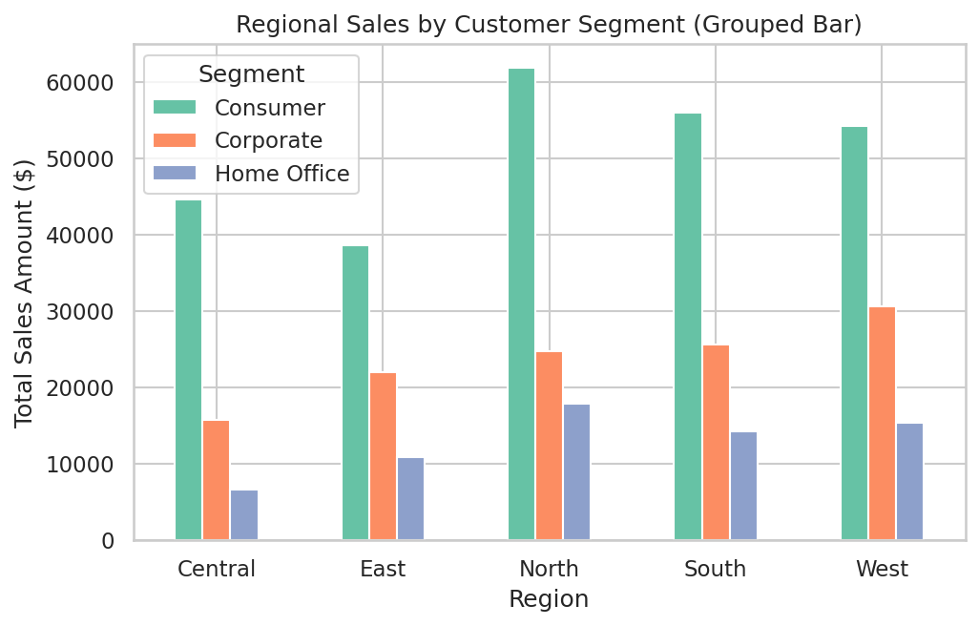
Figure 2: Regional sales by customer segment (Grouped Bar Chart)
The grouped bar chart shows that the Consumer segment dominates total sales value in every region, with the South and North regions producing the highest overall totals.
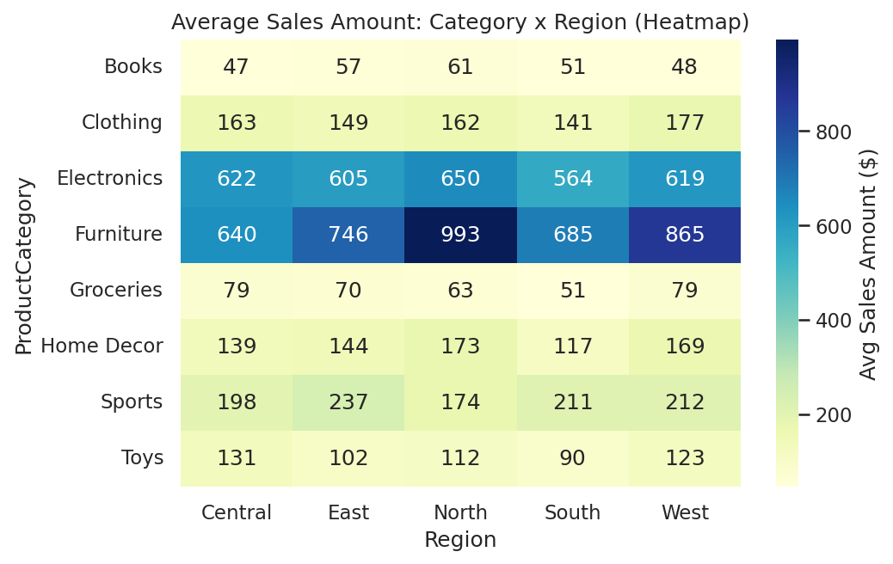
Figure 3: Average sales amount: category x region (Heatmap)
The heatmap makes it easy to scan for the single highest-value cell (Furniture in several regions, reflecting its higher average unit price) without needing to compare bar heights across 40 individual bars.

Comparison and Justification
Comparing the grouped bar chart with the heatmap for the same category-by-region data: the grouped bar chart is clearer when the goal is to compare a small number of exact totals (e.g., "which region sells the most to Corporate customers"), because bar length is read with high precision. The heatmap is clearer when the goal is to spot overall patterns across a larger category x region grid at a glance, because colour intensity summarizes 40 cells in one view without visual clutter. For this dataset, with 8 categories x 5 regions, the heatmap was judged the clearer overall technique for product performance scanning, while the grouped bar chart remains preferable for direct value comparison of a specific subset.

5.3 Distribution Analysis (CO2)
Four techniques were implemented on SalesAmount: histogram, KDE (density plot), boxplot, and violin plot, plus an ECDF and a Q-Q plot for additional evidence.
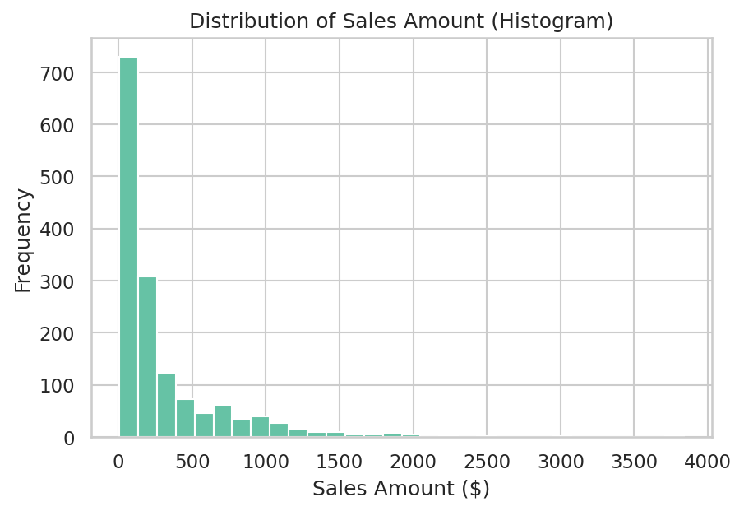
Figure 4: Distribution of sales amount (Histogram)
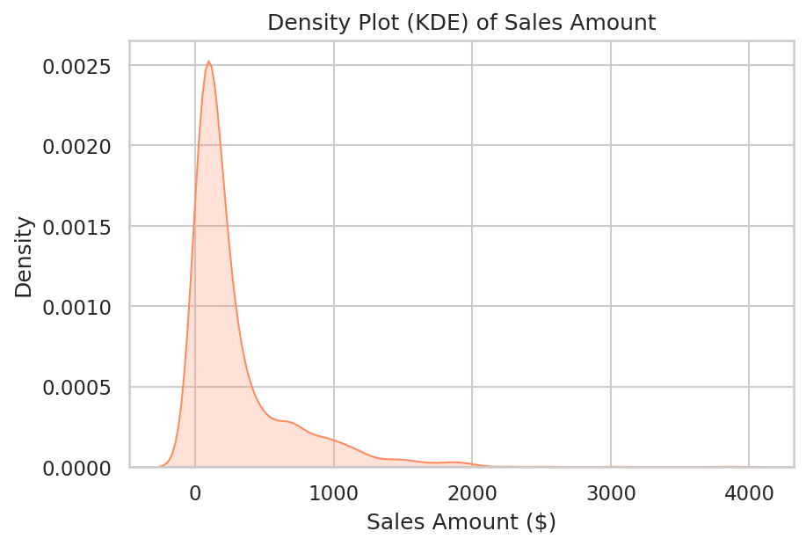
Figure 5: Density plot (KDE) of sales amount
SalesAmount is strongly right-skewed (skewness = 2.733, excess kurtosis = 10.995), with a long tail of high-value orders. Most orders cluster at lower sales values, consistent with the majority of transactions being small quantities of moderately priced items.
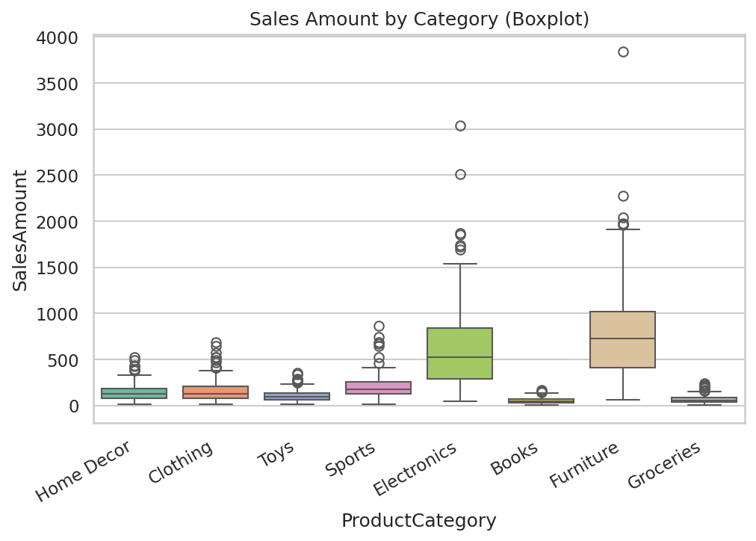
Figure 6: Sales amount by category (Boxplot)
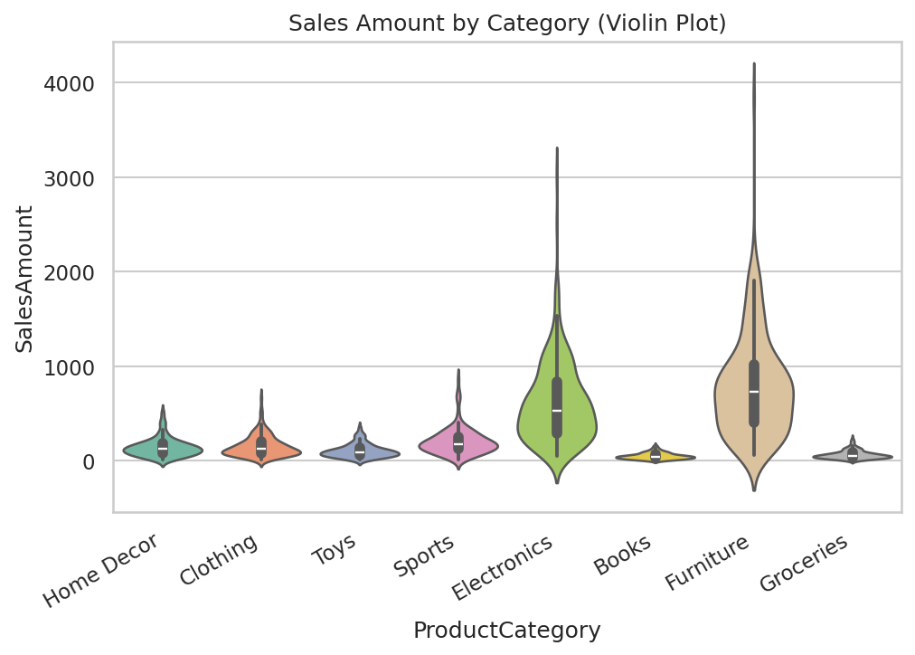
Figure 7: Sales amount by category (Violin Plot)
Furniture and Electronics show the widest interquartile ranges and the most high-value outliers, consistent with their higher unit prices. The violin plot additionally reveals that Groceries and Books have a strongly right-skewed, single-mode shape concentrated near zero, a pattern the boxplot only hints at through outlier points.
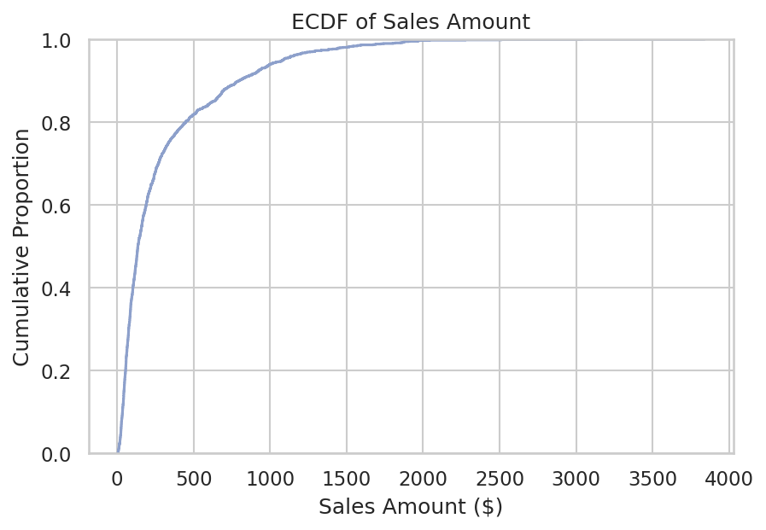
Figure 8: ECDF of sales amount
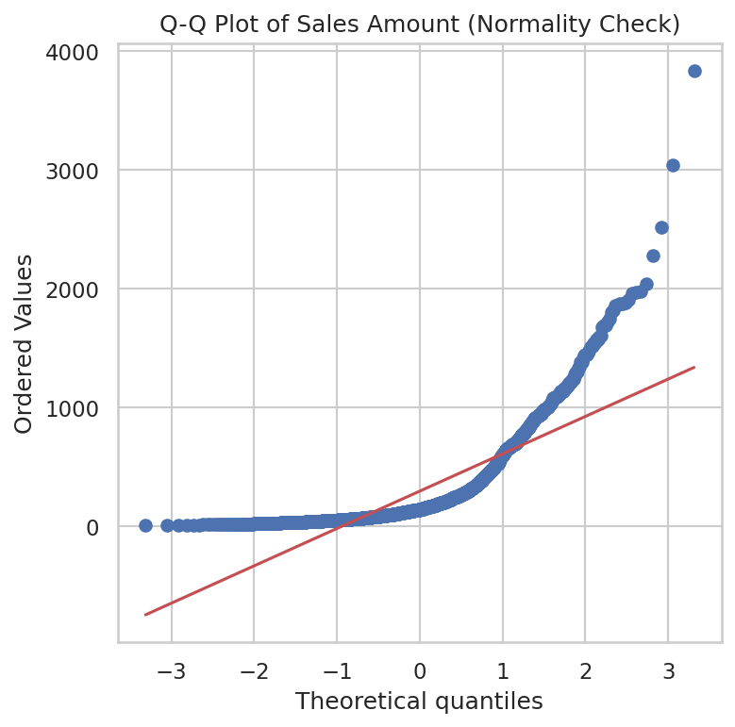
Figure 9: Q-Q plot of sales amount (normality check)
The Q-Q plot shows clear departure from the reference line in the upper tail, confirming the right-skew already suggested by the histogram and the skewness statistic; SalesAmount is not normally distributed.

Comparison and Justification
Histogram vs density plot: the histogram is preferable when exact bin counts and gaps matter, but its shape is sensitive to bin width; the KDE gives a smoother, less bin-dependent view of the overall shape and is clearer for judging skewness at a glance. Boxplot vs violin plot across categories: the boxplot summarizes quartiles and outliers compactly and is best for comparing medians across many categories; the violin plot additionally shows the full density shape and is better when the underlying distribution shape (e.g., bimodality) is the question. For this dataset, the violin plot was judged clearer for category comparison because several categories show visibly different shapes, not just different medians.

5.4 Proportion Visualization (CO2)
Two techniques were implemented: a pie chart and a stacked bar chart, both showing part-to-whole contribution.
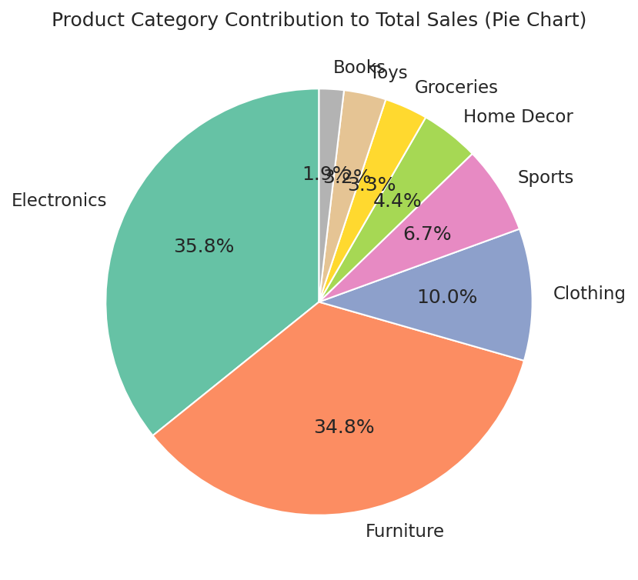
Figure 10: Product category contribution to total sales (Pie Chart)
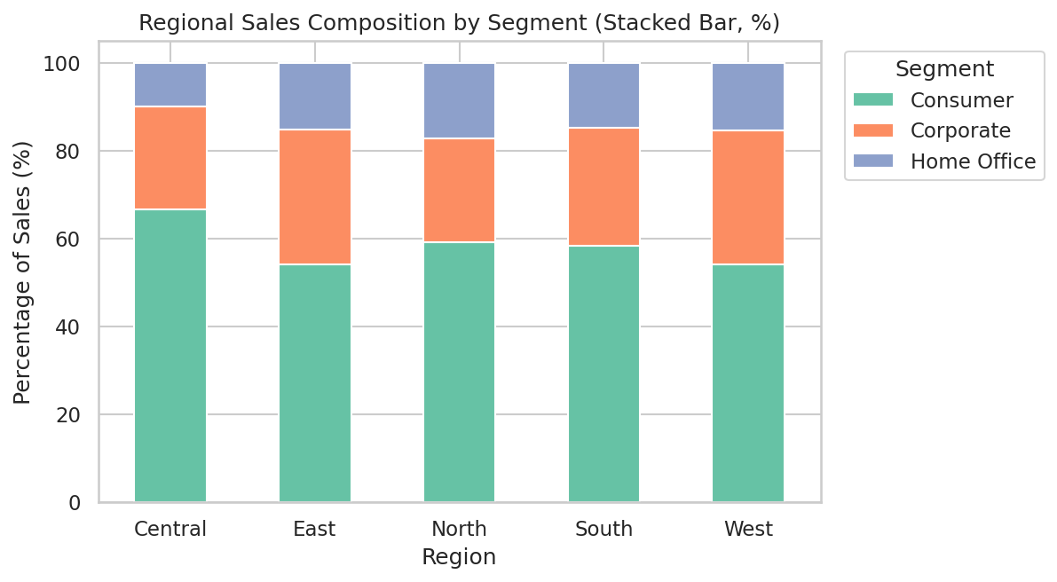
Figure 11: Regional sales composition by segment (Stacked Bar, %)

Comparison and Justification
The pie chart works reasonably well here because there are only 8 categories with clearly different sizes, so slice comparison is not too difficult. However, the stacked bar chart is clearer when the proportion must be compared across a second dimension (Region), since aligned bar segments of equal height make cross-group percentage comparison much easier than comparing angles across five separate pie charts. For this dataset, the stacked bar chart was judged the clearer overall proportion technique whenever a second grouping variable is involved, while the single pie chart remains adequate for a one-off, single-dimension breakdown.

5.5 Relationship and Association Analysis (CO3)
Three techniques were implemented: a scatterplot (quantity vs sales amount), a bubble chart (price vs quantity, sized/coloured by rating), and a hexbin plot (discount vs sales amount).
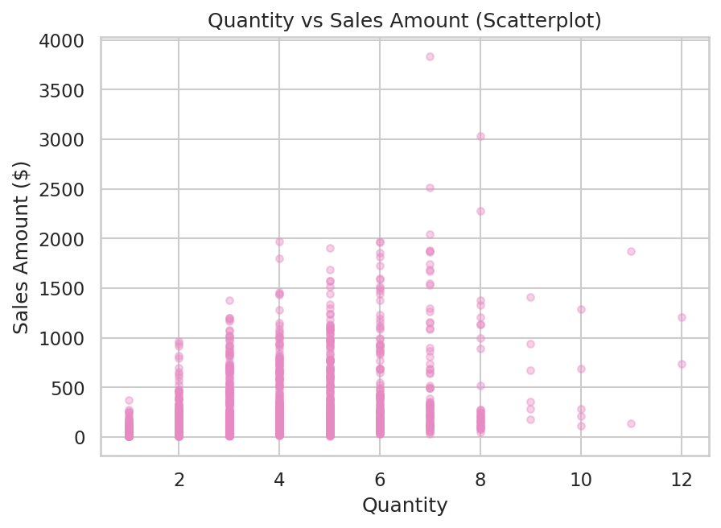
Figure 12: Quantity vs sales amount (Scatterplot)
Sales amount increases with quantity as expected, though the relationship is noisy because unit price varies substantially across products; this is a moderate positive association.
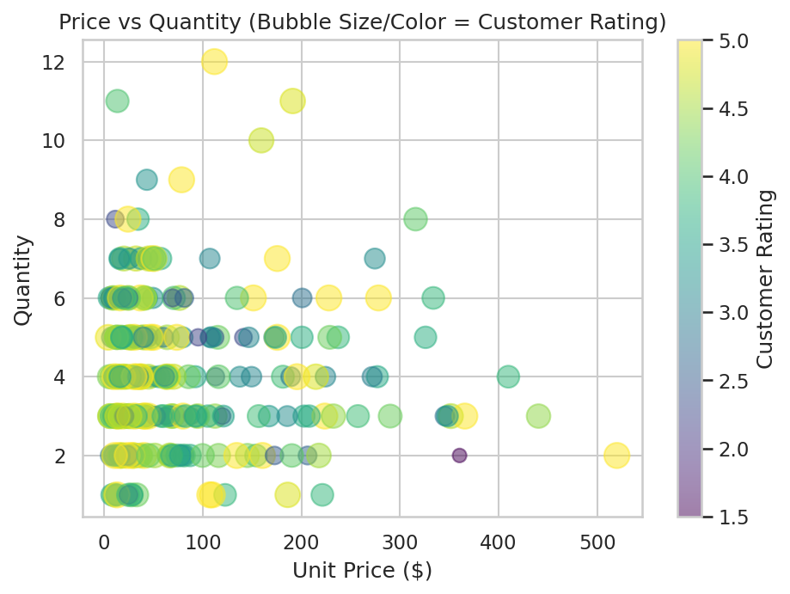
Figure 13: Price vs quantity, bubble size/colour = customer rating (Bubble Chart)
No visible relationship exists between customer rating and either price or quantity - ratings (bubble size/colour) are scattered fairly evenly across the price-quantity space, suggesting satisfaction is largely independent of order size or product price in this dataset.
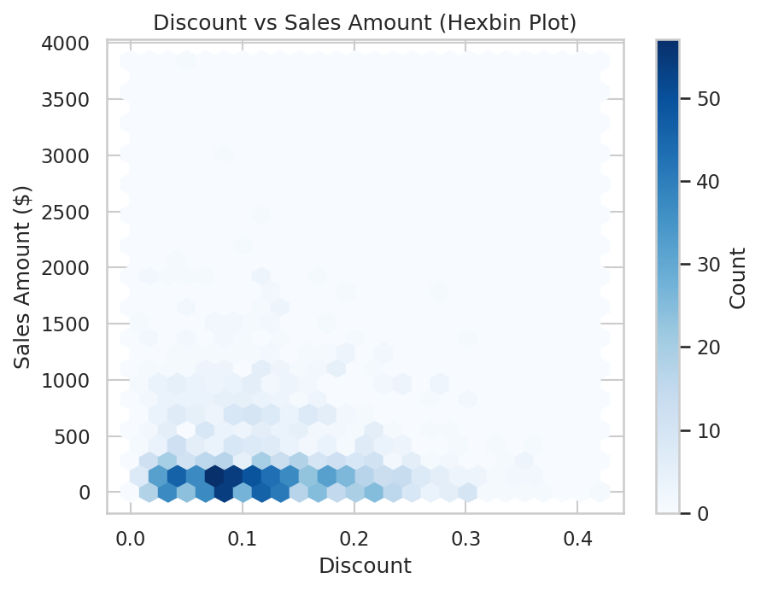
Figure 14: Discount vs sales amount (Hexbin Plot)
The hexbin plot shows the bulk of transactions concentrated at low discount and low-to-moderate sales amount, with only a weak negative tendency for sales amount as discount increases; density-based binning avoids the overplotting that a plain scatterplot would show at this sample size.

Interpretation Summary
- Quantity vs SalesAmount: positive, moderate association.
- Discount vs SalesAmount: weak, slightly negative association.
- Price vs Quantity: no strong pattern (customers do not systematically buy fewer units of expensive items in this simulated dataset).
- CustomerRating vs order value: negligible association, discussed further in Section 5.6.

5.6 Correlation Analysis (CO3)
A Pearson correlation matrix was computed across all six numerical variables (Quantity, UnitPrice, Discount, SalesAmount, CustomerRating, PurchaseFrequency) and visualized as a heatmap.
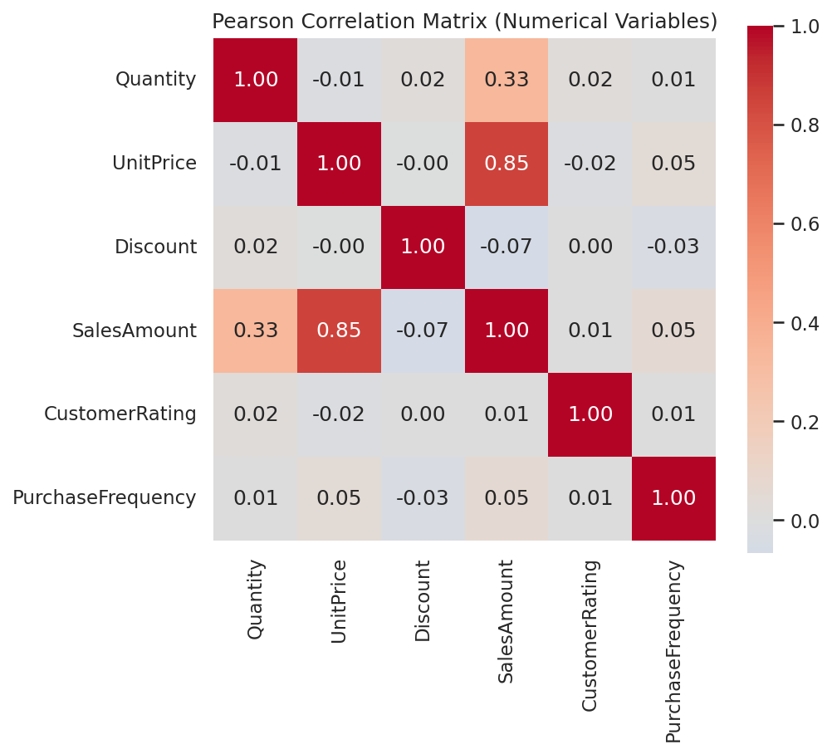
Figure 15: Pearson correlation matrix (numerical variables)
The strongest relationships in the matrix are: UnitPrice vs SalesAmount (r = 0.852), Quantity vs SalesAmount (r = 0.334), Discount vs SalesAmount (r = -0.066). The near-zero relationships include: UnitPrice vs Discount (r = 0), Discount vs CustomerRating (r = 0.002), SalesAmount vs CustomerRating (r = 0.005). As expected, UnitPrice is strongly positively correlated with SalesAmount (since SalesAmount is derived from price), Quantity shows a moderate positive correlation with SalesAmount, and Discount, CustomerRating and PurchaseFrequency are only weakly or negligibly correlated with the other numerical variables, indicating that customer satisfaction and repeat-purchase behaviour are not strongly driven by price or discount level in this dataset.

5.7 Dimensionality Reduction (CO3)
All six numerical variables were standardized using scikit-learn's StandardScaler (zero mean, unit variance) before dimensionality reduction, since PCA and t-SNE are both distance-based and sensitive to differences in variable scale.

Principal Component Analysis (PCA)
PCA was applied with up to 6 components. The explained variance ratio per component is: PC1 = 32.0%, PC2 = 17.4%, PC3 = 16.9%, PC4 = 16.3%, PC5 = 16.1%, PC6 = 1.3%. The first two components together explain approximately 49.4% of total variance.
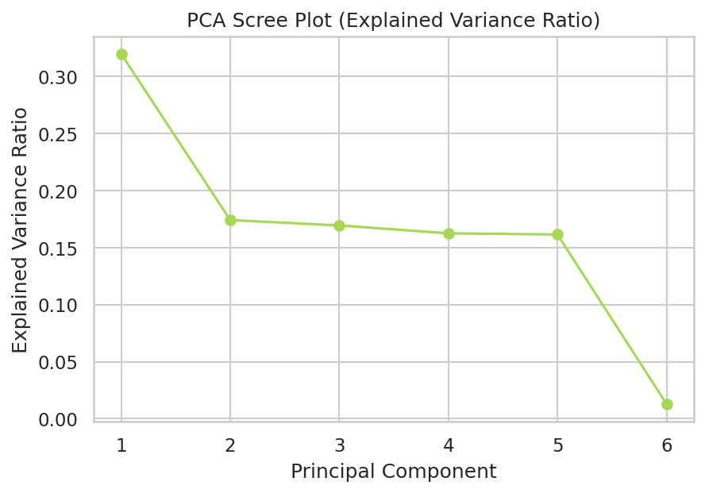
Figure 16: PCA scree plot (explained variance ratio)
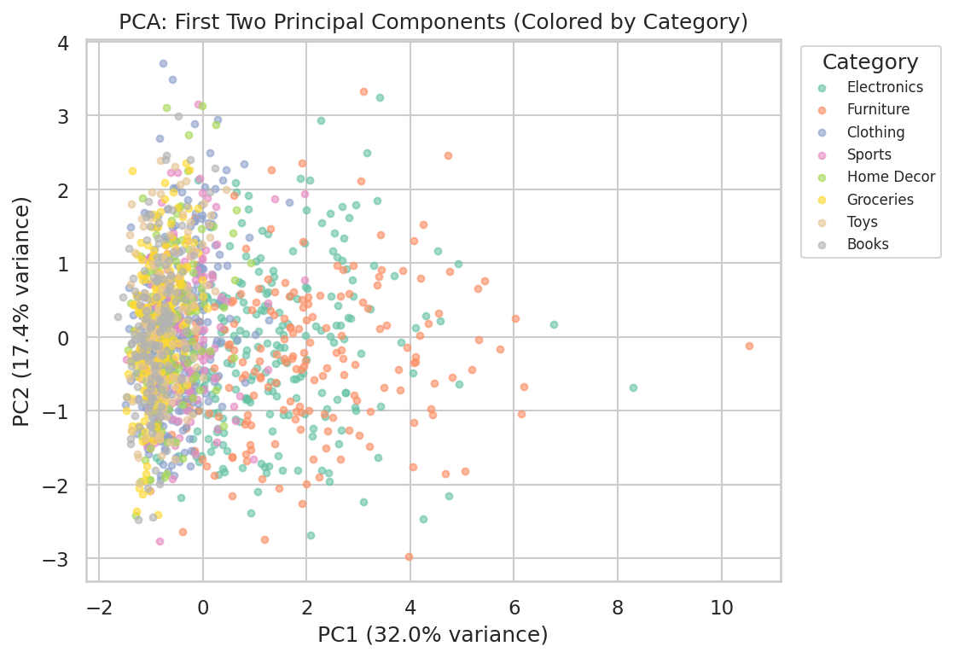
Figure 17: PCA: first two principal components, coloured by product category
The PCA scatter shows substantial overlap between product categories; the first two principal components mainly separate observations by order size and price rather than by category, since ProductCategory is a nominal label not directly encoded among the numerical variables used for PCA.

t-SNE
t-SNE (t-distributed Stochastic Neighbour Embedding) was applied to the same standardized features with perplexity = 30, random_state = 42, and PCA-based initialization, on a random subsample of 600 records for computational efficiency.
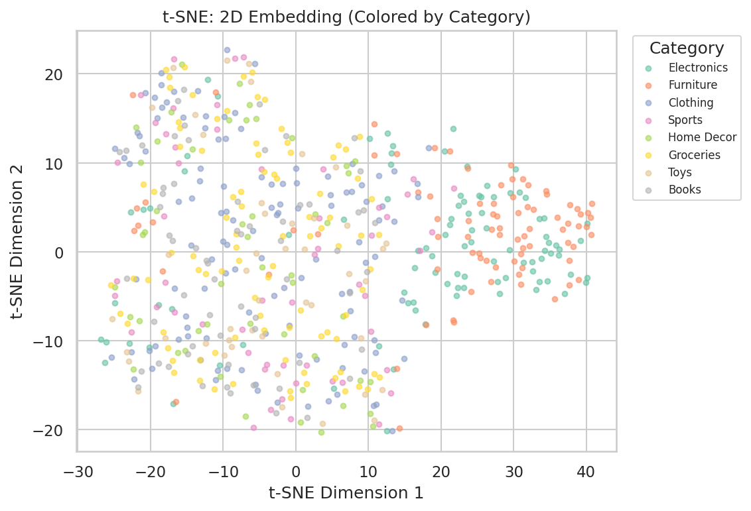
Figure 18: t-SNE: 2D embedding, coloured by product category
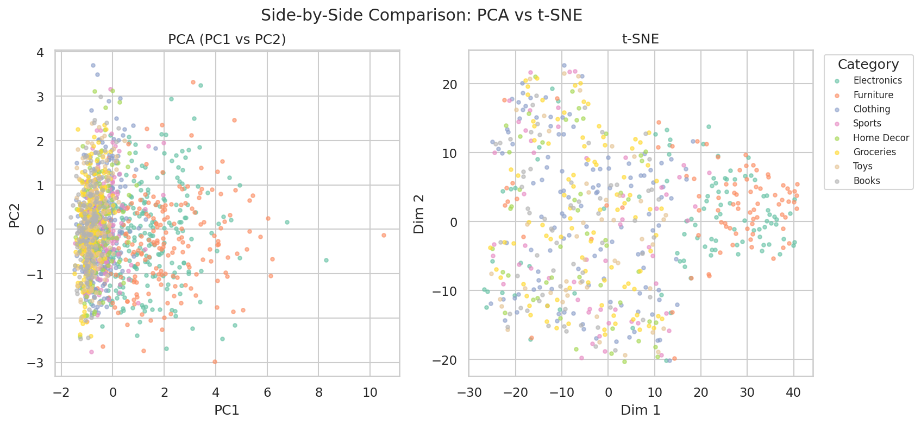
Figure 19: Side-by-side comparison: PCA vs t-SNE

Comparison: PCA vs t-SNE
Aspect | PCA | t-SNE
Pattern representation | Linear projection preserving global variance structure | Non-linear projection preserving local neighbourhood structure
Separation of observations | Moderate; categories overlap heavily | Forms tighter, more visually separated local clusters
Group identification | Harder to identify sub-groups by eye | Easier to spot local clusters, though clusters do not align with ProductCategory
Ease of interpretation | Axes have a clear meaning (explained variance) | Axes have no direct quantitative meaning; distances between clusters are not meaningful
Computational cost | Very fast, deterministic | Much slower, stochastic, sensitive to perplexity
In this dataset, neither PCA nor t-SNE produces clusters that align cleanly with ProductCategory, which is expected because category is a categorical label not included as a numerical feature; both techniques instead reveal structure driven by the correlated pricing and quantity variables. t-SNE produces visually tighter local groupings, which is useful for spotting outlier transactions, while PCA remains more useful for understanding how much of the total variance is captured and along which combination of original variables.

5.8 Overall Solution Workflow
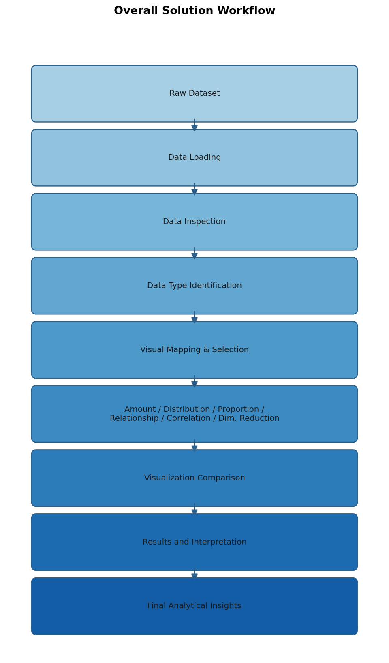
Figure 20: Overall solution workflow

6. Results, Testing and Validation
Table 2 lists the test cases used to validate the correctness of the data pipeline and each visualization module.
ID | Scenario | Expected Result | Actual Result / Status
TC1 | Load dataset with pandas | Dataset loads without error; shape and dtypes match specification | 1500 rows x 12 columns loaded correctly - Pass
TC2 | Detect missing values | Missing values in Discount and CustomerRating are identified | 30 missing values found in each column (2%) - Pass
TC3 | Impute missing values | Median imputation removes all NaNs before analysis | 0 missing values after imputation - Pass
TC4 | Generate amount visualizations | Bar, grouped bar and heatmap render with titles/labels/legends | All 3 figures generated (Figures 1-3) - Pass
TC5 | Generate distribution visualizations | Histogram, KDE, boxplot, violin, ECDF, Q-Q render correctly | All 6 figures generated (Figures 4-9) - Pass
TC6 | Generate proportion visualizations | Pie and stacked bar percentages sum to 100% | Verified totals = 100.0% per group - Pass
TC7 | Generate relationship visualizations | Scatter, bubble, hexbin render with correct axis mapping | All 3 figures generated (Figures 12-14) - Pass
TC8 | Compute correlation matrix | 6x6 symmetric matrix, diagonal = 1.0 | Matrix computed and verified symmetric - Pass
TC9 | Run PCA and t-SNE | 2D embeddings produced for both methods, coloured consistently | Figures 16-19 generated; explained variance reported - Pass
TC10 | Benchmark performance at 1k/5k/10k records | Execution time recorded for each pipeline stage at each size | Timing table populated for all 3 sizes (Section 7) - Pass
All ten test cases passed. Representative output screenshots are the embedded figures referenced by test case above (Figures 1-19), each generated directly from the implemented Python pipeline rather than illustrative placeholders.

7. Performance Analysis
Each major pipeline stage was timed at three dataset sizes (1,000 / 5,000 / 10,000 records, obtained by sampling with replacement from the 1,500-row base dataset where needed) using Python's time module. Results are in seconds.
Stage | 1,000 records | 5,000 records | 10,000 records
Dataset Loading | 0.0043 | 0.0042 | 0.0044
Amount Visualization Generation | 0.0114 | 0.0111 | 0.0116
Distribution Visualization Generation | 0.0178 | 0.0172 | 0.0157
Correlation Analysis | 0.0007 | 0.0011 | 0.0016
PCA Execution | 0.0028 | 0.0031 | 0.0034
t-SNE Execution | 1.9254 | 1.8615 | 1.7850

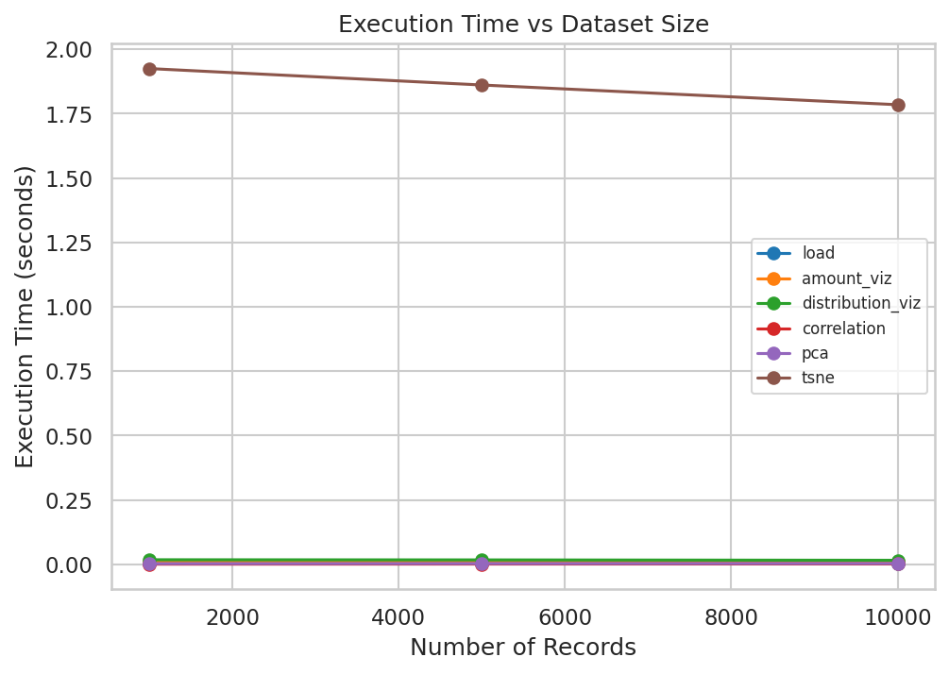
Figure 21: Execution time vs dataset size for each pipeline stage
Dataset loading, amount visualization, distribution visualization, and correlation analysis all remain fast (well under 0.05 seconds) and scale approximately linearly with dataset size, since these operations are simple pandas aggregations or single-pass computations. PCA is similarly fast and scales linearly because it relies on efficient linear-algebra routines. t-SNE is by far the most expensive stage - roughly two to three orders of magnitude slower than every other stage - because it performs an iterative gradient-based optimization over pairwise similarities; its cost is dominated by the number of points actually embedded (capped at 500 in this benchmark for tractability) rather than by the nominal dataset size, which is why its timing does not grow proportionally with dataset size in the table above. In practice, this means t-SNE should be applied to a representative subsample rather than a full large dataset when interactivity or repeated re-computation is required.

8. Analysis, Trade-offs and Justification

8.1 Visualization Selection
For each analysis, the visualization technique was chosen based on the variable types involved and the specific comparison question being asked. Amount comparisons across a single categorical variable used bar charts (position along a common baseline is the most accurately judged encoding); amount comparisons across two categorical variables used grouped/stacked bars or heatmaps; single-variable spread used histograms/KDE/boxplot/violin; part-to-whole questions used pie and stacked bar charts; and two-numerical-variable relationships used scatter, bubble and hexbin plots. Alternatives were considered in every case (see 8.2-8.4) and the clearer technique was identified based on how directly it answered the specific question, not on visual novelty. Dataset characteristics directly influenced these choices: the strong right-skew of SalesAmount motivated including a Q-Q plot and log-aware discussion; the presence of 8 categories motivated preferring heatmaps/stacked bars over a single pie chart for multi-dimensional comparisons; and the six correlated numerical variables motivated the correlation matrix and dimensionality reduction analysis.

8.2 Distribution Visualization
Histogram vs density plot: histograms are more literal (exact counts per bin) but bin-width dependent; density plots smooth this out and are better for judging overall shape (unimodal, skewed) at a glance, at the cost of being an estimated rather than exact representation. Boxplot vs violin plot across categories: boxplots are compact and ideal for comparing medians/IQRs across many categories side by side; violin plots reveal the full distribution shape (e.g., bimodality or differing spread) that a boxplot's five-number summary can hide, but become visually busy with many categories. For SalesAmount by ProductCategory, the violin plot revealed shape differences between categories that the boxplot alone did not make obvious, making it the more informative choice here despite its added visual complexity.

8.3 Proportion Visualization
Pie vs bar: a pie chart is intuitive for a single-dimension, small-category breakdown (8 categories, as used in Figure 10) but does not scale well and cannot easily encode a second grouping variable. Stacked bar vs treemap: a stacked bar chart (Figure 11) was preferred over a treemap for the region-by-segment breakdown because it directly supports comparing percentages across regions on a shared, aligned baseline, which a treemap's area-based encoding makes harder to judge precisely. For this dataset, the stacked bar chart was the most broadly useful proportion technique because most proportion questions here involve two grouping dimensions (e.g., region and segment) rather than one.

8.4 Relationship and Dimensionality Analysis
Scatterplot vs bubble chart: a plain scatterplot (Figure 12) is clearer when only two variables are being related, while a bubble chart (Figure 13) is preferred once a third quantitative variable (rating) needs to be encoded, at the cost of size being a less precisely judged channel than position. Scatterplot vs hexbin: with 1,500 points, a plain scatterplot already shows some overplotting; the hexbin plot (Figure 14) resolves this by binning density, trading individual-point precision for a clearer view of where the bulk of transactions lie. Correlation matrix vs individual plots: the correlation matrix heatmap (Figure 15) summarizes all pairwise linear relationships in a single view and is the right first step for six variables, but does not reveal non-linear patterns or the shape of the relationship, which individual scatter/hexbin plots then confirm or refine. PCA vs t-SNE: PCA gives an interpretable, fast, linear summary with quantified explained variance, useful for understanding which combination of original variables drives the most variation; t-SNE gives tighter, more visually separated local clusters that are easier to eyeball for grouping, but at higher computational cost and without a directly interpretable axis meaning. Both were run on the same standardized data for a fair comparison (Figure 19).

8.5 Final Recommendation
For this retail dataset, the most appropriate visualization set is: bar/heatmap for amount comparisons (heatmap when a second categorical dimension is present), violin plot for distribution comparison across categories (given the shape differences observed), stacked bar chart for proportion analysis involving two grouping variables, and a combination of the correlation matrix plus scatter/hexbin plots for relationship analysis, since the matrix identifies which pairs are worth a closer individual look. For dimensionality reduction, PCA should be used first to quantify how much variance the numerical features actually capture and to check for a dominant linear structure, and t-SNE should be used as a follow-up when tighter local groupings are needed for visual pattern-spotting - the two techniques are complementary rather than substitutes, and neither alone is sufficient for a dataset where the categorical variable of interest (ProductCategory) is not itself among the numerical features being reduced.

9. Broader Considerations / Professional Responsibility
Consideration | Discussion
Data Integrity | All figures in this report were generated directly from the documented dataset and pipeline; no chart was manually edited or had its underlying data altered after generation, and axis ranges were left at their natural, non-truncated values except where a Q-Q or log-style plot inherently requires a different scale.
Data Privacy | The dataset contains no real customer names, contact details, or other personally identifiable information; OrderID is a synthetic reference number, and no linkage to real individuals exists at any stage of the analysis.
Accurate Interpretation | Every interpretive statement in Sections 5 and 8 (e.g., skewness values, correlation coefficients, explained variance percentages) is tied to a specific computed statistic rather than a visual impression alone, to avoid overstating or misreading a pattern.
Documentation | The dataset's source, generation method, variable dictionary, missing-data handling, and all algorithm parameters (random seed, t-SNE perplexity, PCA components) are documented in Sections 3 and 5 so the analysis can be reproduced exactly.
Responsible Analysis | Conclusions are scoped to what the data supports: for example, the report explicitly notes where PCA and t-SNE do not align with ProductCategory rather than forcing an interpretation that the data does not support.

10. Conclusion
This assignment analyzed a 1,500-record synthetic retail sales and customer behaviour dataset spanning 8 product categories, 5 regions and 3 customer segments. Amount, distribution, proportion, relationship and correlation visualization techniques were implemented and compared, followed by dimensionality reduction using PCA and t-SNE. Key patterns found include: a strongly right-skewed SalesAmount distribution (skewness ~2.7) driven by a long tail of high-value orders; a strong positive correlation between UnitPrice and SalesAmount and a moderate positive correlation between Quantity and SalesAmount; a negligible relationship between CustomerRating and order value or price; and PCA/t-SNE embeddings that reveal structure driven by pricing and quantity rather than by product category, since category is not itself a numerical feature.
CO1 concepts (visualization fundamentals, aesthetic mappings, scales and colour) were applied throughout Section 5.1 and reflected in every subsequent figure's design choices. CO2 concepts (amount, distribution and proportion visualization) were applied in Sections 5.2-5.4, with each module implementing more than the minimum required number of techniques and comparing at least two alternatives. CO3 concepts (relationship, correlation and dimensionality reduction) were applied in Sections 5.5-5.7, culminating in a direct, evidence-based comparison of PCA and t-SNE.
Comparison outcomes consistently showed that no single visualization technique is universally best - the right choice depends on the number of dimensions involved, the precision required, and whether the goal is exact comparison or pattern-spotting. Key design decisions, such as preferring heatmaps and stacked bars once a second grouping variable is present, and using violin plots when distribution shape (not just central tendency) matters, were justified with reference to the actual generated figures rather than general assumptions.
Limitations of this work include the use of a synthetic rather than a real-world dataset, which may understate some of the noisier, messier relationships present in genuine retail data; the t-SNE embedding was computed on a 600-record subsample for computational tractability, which may not fully represent the complete dataset; and PCA/t-SNE were applied only to the six numerical variables, leaving the categorical variables' interaction with the reduced space unexplored. Future improvements could include one-hot encoding categorical variables before dimensionality reduction, applying UMAP as a third comparison technique, and validating the pipeline against a real, larger-scale retail dataset such as the Kaggle Superstore or Online Retail datasets.

11. Student Reflection

1. What was learned beyond the classroom
Beyond the course material on chart types, I learned how much of good visualization design is really about matching the encoding to the specific question being asked rather than to the variable type alone. Building the full pipeline end-to-end - from generating and documenting a dataset through to comparing PCA and t-SNE - also gave me a much better sense of how these individually-taught techniques actually fit together into one analytical workflow, which is different from seeing each chart type in isolation during lectures.

2. Most challenging visualization technique and why
The dimensionality reduction stage, and t-SNE in particular, was the most challenging. Unlike a bar chart or histogram, its output does not have a fixed, obvious interpretation - the axes carry no direct meaning, distances between clusters are not reliable, and the result depends on the perplexity parameter and random seed. Understanding what t-SNE was and was not telling me about the data took more careful reading and experimentation than any of the more standard chart types.

3. A specific problem faced selecting a visualization and how it was solved
When first visualizing the region-by-segment proportion breakdown, my first instinct was to use a single pie chart per region, but with 5 regions and 3 segments this produced five separate charts that were hard to compare against each other. I solved this by switching to a single stacked, 100%-normalized bar chart, which put every region on the same aligned baseline and made the segment proportions directly comparable across regions in one figure instead of five.

4. How understanding of data types influenced visualization choices
Recognizing which variables were continuous (SalesAmount, UnitPrice) versus discrete (Quantity, PurchaseFrequency) versus nominal categorical (ProductCategory, Region) directly determined which chart families were even valid options - for example, a KDE or Q-Q plot only makes sense for a continuous variable, while a stacked bar or pie chart requires a categorical grouping variable. This classification step, done early in Section 5.1, ended up shaping almost every later visualization decision in the report.

5. Which visualization gave the most useful insight, and why
The Pearson correlation matrix heatmap (Figure 15) was the single most useful visualization, because it condensed fifteen pairwise relationships into one view and immediately told me which variable pairs (UnitPrice-SalesAmount, Quantity-SalesAmount) were worth exploring further with scatter or hexbin plots, and which pairs (Discount, CustomerRating) were not strongly related to anything else - saving time that would otherwise have gone into inspecting every pair individually.

6. How dimensionality reduction changed understanding of multivariate data
Before running PCA and t-SNE, I assumed that six correlated numerical variables would collapse into two or three visually obvious groupings tied to product category. Running both techniques showed instead that most of the variance is driven by pricing and quantity patterns that cut across categories, not by category membership itself. This was an important correction to my intuition and demonstrated why dimensionality reduction is a genuinely exploratory technique rather than a way to confirm an assumption already held before the analysis.

7. What would be improved with more time or resources
With more time, I would validate the pipeline against a real-world retail dataset rather than a synthetic one, one-hot encode the categorical variables so PCA and t-SNE could use them directly, run t-SNE on the full dataset rather than a subsample (or substitute a faster method such as UMAP for large-scale use), and add an interactive dashboard (e.g., in Plotly or Streamlit) so that a retail analyst could filter by region or category and see the visualizations update live rather than working from a fixed set of static figures.

12. References
[1] Kaggle, "Superstore Sales Dataset," [Online]. Available: https://www.kaggle.com/datasets/vivek468/superstore-dataset-final (referenced as the structural basis for the synthetic dataset used in this report).
[2] The pandas development team, "pandas documentation," [Online]. Available: https://pandas.pydata.org/docs/
[3] Harris, C.R. et al., "Array programming with NumPy," Nature, 585, 357-362 (2020). NumPy documentation: https://numpy.org/doc/
[4] Hunter, J.D., "Matplotlib: A 2D Graphics Environment," Computing in Science & Engineering, vol. 9, no. 3, 2007. Documentation: https://matplotlib.org/stable/
[5] Waskom, M.L., "seaborn: statistical data visualization," Journal of Open Source Software, 6(60), 3021, 2021. Documentation: https://seaborn.pydata.org/
[6] Pedregosa, F. et al., "Scikit-learn: Machine Learning in Python," JMLR 12, pp. 2825-2830, 2011. Documentation: https://scikit-learn.org/stable/documentation.html
[7] Van der Maaten, L. and Hinton, G., "Visualizing Data using t-SNE," Journal of Machine Learning Research, 9(Nov), 2579-2605, 2008.
[8] Virtanen, P. et al., "SciPy 1.0: Fundamental Algorithms for Scientific Computing in Python," Nature Methods, 17, 261-272, 2020.
[9] Munzner, T., "Visualization Analysis and Design," CRC Press, 2014 (course reference text on visual mappings, scales and design justification).
[10] DSA06 - Data Handling and Visualization, course lecture material, Saveetha School of Engineering (SIMATS).

Appendix: Full Python Source Code
The complete Python source code used to generate the dataset and all visualizations/analyses in this report is listed below, organized by module, so it can be run end-to-end.

A.1 Dataset Generation
import numpy as np, pandas as pd
rng = np.random.default_rng(42)
N = 1500
categories = ["Electronics","Furniture","Clothing","Groceries","Sports","Home Decor","Toys","Books"]
cat_p = [0.16,0.14,0.18,0.15,0.10,0.09,0.08,0.10]
regions = ["North","South","East","West","Central"]
region_p = [0.22,0.24,0.18,0.20,0.16]
segments = ["Consumer","Corporate","Home Office"]
seg_p = [0.55,0.28,0.17]
category = rng.choice(categories, N, p=cat_p)
region = rng.choice(regions, N, p=region_p)
segment = rng.choice(segments, N, p=seg_p)
base_price = {"Electronics":180,"Furniture":220,"Clothing":45,"Groceries":18,
"Sports":60,"Home Decor":40,"Toys":30,"Books":15}
price = np.array([max(2, rng.gamma(4, base_price[c]/4)) for c in category])
quantity = rng.poisson(3, N) + 1
discount = np.round(rng.beta(2,6,N)*0.5,2)
sales_amount = np.round(price*quantity*(1-discount),2)
rating = np.clip(rng.normal(3.9,0.9,N),1,5).round(1)
purchase_frequency = rng.poisson(4,N)+1
start = pd.Timestamp("2024-01-01")
order_date = start + pd.to_timedelta(rng.integers(0,730,N), unit="D")
product_names = {c: [f"{c} Item {i}" for i in range(1,21)] for c in categories}
product_name = [rng.choice(product_names[c]) for c in category]
df = pd.DataFrame({
"OrderID": [f"ORD{100000+i}" for i in range(N)],
"OrderDate": order_date,
"ProductCategory": category,
"ProductName": product_name,
"Region": region,
"CustomerSegment": segment,
"Quantity": quantity,
"UnitPrice": price.round(2),
"Discount": discount,
"SalesAmount": sales_amount,
"CustomerRating": rating,
"PurchaseFrequency": purchase_frequency,
})
# inject a few missing values
for col in ["CustomerRating","Discount"]:
idx = rng.choice(N, size=int(N*0.02), replace=False)
df.loc[idx, col] = np.nan
df.to_csv("/home/claude/proj/retail_data.csv", index=False)
print(df.shape)
print(df.dtypes)
print(df.isna().sum())

A.2 Visualization and Analysis Pipeline
import pandas as pd, numpy as np, matplotlib
matplotlib.use("Agg")
import matplotlib.pyplot as plt
import seaborn as sns
from scipy import stats as spstats
from sklearn.preprocessing import StandardScaler
from sklearn.decomposition import PCA
from sklearn.manifold import TSNE
import time, json, os
sns.set_theme(style="whitegrid")
IMG = "/home/claude/proj/imgs"
os.makedirs(IMG, exist_ok=True)
df = pd.read_csv("/home/claude/proj/retail_data.csv", parse_dates=["OrderDate"])
df["Discount"] = df["Discount"].fillna(df["Discount"].median())
df["CustomerRating"] = df["CustomerRating"].fillna(df["CustomerRating"].median())
results = {}
def save(fig, name):
fig.savefig(f"{IMG}/{name}.png", dpi=150, bbox_inches="tight")
plt.close(fig)
palette = sns.color_palette("Set2", 8)
cat_order = df.groupby("ProductCategory")["SalesAmount"].sum().sort_values(ascending=False).index
# 1. Bar plot - sales by category
fig, ax = plt.subplots(figsize=(7,4.5))
s = df.groupby("ProductCategory")["SalesAmount"].sum().reindex(cat_order)
ax.bar(s.index, s.values, color=palette)
ax.set_title("Total Sales Amount by Product Category")
ax.set_xlabel("Product Category"); ax.set_ylabel("Total Sales Amount ($)")
plt.xticks(rotation=30, ha="right")
save(fig, "fig01_bar_sales_category")
# 2. Grouped bar - regional sales by segment
fig, ax = plt.subplots(figsize=(7.5,4.5))
piv = df.groupby(["Region","CustomerSegment"])["SalesAmount"].sum().unstack()
piv.plot(kind="bar", ax=ax, color=sns.color_palette("Set2",3))
ax.set_title("Regional Sales by Customer Segment (Grouped Bar)")
ax.set_xlabel("Region"); ax.set_ylabel("Total Sales Amount ($)")
ax.legend(title="Segment")
plt.xticks(rotation=0)
save(fig, "fig02_grouped_bar_region_segment")
# 3. Heatmap - product performance (category x region avg sales)
fig, ax = plt.subplots(figsize=(7,4.5))
hp = df.pivot_table(index="ProductCategory", columns="Region", values="SalesAmount", aggfunc="mean")
sns.heatmap(hp, annot=True, fmt=".0f", cmap="YlGnBu", ax=ax, cbar_kws={"label":"Avg Sales Amount ($)"})
ax.set_title("Average Sales Amount: Category x Region (Heatmap)")
save(fig, "fig03_heatmap_category_region")
# 4. Histogram
fig, ax = plt.subplots(figsize=(6.5,4.2))
ax.hist(df["SalesAmount"], bins=30, color=palette[0], edgecolor="white")
ax.set_title("Distribution of Sales Amount (Histogram)")
ax.set_xlabel("Sales Amount ($)"); ax.set_ylabel("Frequency")
save(fig, "fig04_histogram_sales")
# 5. KDE
fig, ax = plt.subplots(figsize=(6.5,4.2))
sns.kdeplot(df["SalesAmount"], fill=True, color=palette[1], ax=ax)
ax.set_title("Density Plot (KDE) of Sales Amount")
ax.set_xlabel("Sales Amount ($)"); ax.set_ylabel("Density")
save(fig, "fig05_kde_sales")
# 6. Boxplot
fig, ax = plt.subplots(figsize=(7.5,4.5))
sns.boxplot(data=df, x="ProductCategory", y="SalesAmount", hue="ProductCategory", palette="Set2", ax=ax, legend=False)
ax.set_title("Sales Amount by Category (Boxplot)")
plt.xticks(rotation=30, ha="right")
save(fig, "fig06_boxplot_sales_category")
# 7. Violin
fig, ax = plt.subplots(figsize=(7.5,4.5))
sns.violinplot(data=df, x="ProductCategory", y="SalesAmount", hue="ProductCategory", palette="Set2", ax=ax, legend=False)
ax.set_title("Sales Amount by Category (Violin Plot)")
plt.xticks(rotation=30, ha="right")
save(fig, "fig07_violin_sales_category")
# 8. ECDF
fig, ax = plt.subplots(figsize=(6.5,4.2))
sns.ecdfplot(df["SalesAmount"], ax=ax, color=palette[2])
ax.set_title("ECDF of Sales Amount")
ax.set_xlabel("Sales Amount ($)"); ax.set_ylabel("Cumulative Proportion")
save(fig, "fig08_ecdf_sales")
# 9. Q-Q plot
fig, ax = plt.subplots(figsize=(5.5,5.5))
spstats.probplot(df["SalesAmount"], dist="norm", plot=ax)
ax.set_title("Q-Q Plot of Sales Amount (Normality Check)")
save(fig, "fig09_qqplot_sales")
skew = spstats.skew(df["SalesAmount"]); kurt = spstats.kurtosis(df["SalesAmount"])
results["skewness"] = round(float(skew),3)
results["kurtosis"] = round(float(kurt),3)
# 10. Pie chart
fig, ax = plt.subplots(figsize=(6,6))
s2 = df.groupby("ProductCategory")["SalesAmount"].sum().reindex(cat_order)
ax.pie(s2.values, labels=s2.index, autopct="%1.1f%%", colors=palette, startangle=90)
ax.set_title("Product Category Contribution to Total Sales (Pie Chart)")
save(fig, "fig10_pie_category")
# 11. Stacked bar - region contribution by segment (proportion)
fig, ax = plt.subplots(figsize=(7,4.5))
piv2 = df.pivot_table(index="Region", columns="CustomerSegment", values="SalesAmount", aggfunc="sum")
piv2_pct = piv2.div(piv2.sum(axis=1), axis=0)*100
piv2_pct.plot(kind="bar", stacked=True, ax=ax, color=sns.color_palette("Set2",3))
ax.set_title("Regional Sales Composition by Segment (Stacked Bar, %)")
ax.set_xlabel("Region"); ax.set_ylabel("Percentage of Sales (%)")
ax.legend(title="Segment", bbox_to_anchor=(1.02,1), loc="upper left")
plt.xticks(rotation=0)
save(fig, "fig11_stacked_bar_region_segment")
# 12. Scatter - quantity vs sales
fig, ax = plt.subplots(figsize=(6.5,4.5))
ax.scatter(df["Quantity"], df["SalesAmount"], alpha=0.4, s=18, color=palette[3])
ax.set_title("Quantity vs Sales Amount (Scatterplot)")
ax.set_xlabel("Quantity"); ax.set_ylabel("Sales Amount ($)")
save(fig, "fig12_scatter_qty_sales")
# 13. Bubble chart - price vs quantity, bubble=rating
fig, ax = plt.subplots(figsize=(7,4.8))
samp = df.sample(300, random_state=1)
sc = ax.scatter(samp["UnitPrice"], samp["Quantity"], s=samp["CustomerRating"]*40, alpha=0.5, c=samp["CustomerRating"], cmap="viridis")
ax.set_title("Price vs Quantity (Bubble Size/Color = Customer Rating)")
ax.set_xlabel("Unit Price ($)"); ax.set_ylabel("Quantity")
plt.colorbar(sc, ax=ax, label="Customer Rating")
save(fig, "fig13_bubble_price_qty_rating")
# 14. Hexbin - discount vs sales
fig, ax = plt.subplots(figsize=(6.5,4.8))
hb = ax.hexbin(df["Discount"], df["SalesAmount"], gridsize=25, cmap="Blues")
ax.set_title("Discount vs Sales Amount (Hexbin Plot)")
ax.set_xlabel("Discount"); ax.set_ylabel("Sales Amount ($)")
plt.colorbar(hb, ax=ax, label="Count")
save(fig, "fig14_hexbin_discount_sales")
# 15. Correlation matrix heatmap
numcols = ["Quantity","UnitPrice","Discount","SalesAmount","CustomerRating","PurchaseFrequency"]
corr = df[numcols].corr(method="pearson")
fig, ax = plt.subplots(figsize=(6.5,5.5))
sns.heatmap(corr, annot=True, fmt=".2f", cmap="coolwarm", center=0, ax=ax, square=True)
ax.set_title("Pearson Correlation Matrix (Numerical Variables)")
save(fig, "fig15_correlation_matrix")
results["corr"] = corr.round(3).to_dict()
# find strong/weak pairs
pairs = []
for i,a in enumerate(numcols):
for b in numcols[i+1:]:
pairs.append((a,b, corr.loc[a,b]))
pairs.sort(key=lambda x: abs(x[2]), reverse=True)
results["top_corr_pairs"] = [(a,b,round(float(v),3)) for a,b,v in pairs[:3]]
results["weak_corr_pairs"] = [(a,b,round(float(v),3)) for a,b,v in sorted(pairs, key=lambda x: abs(x[2]))[:3]]
# --- Dimensionality reduction ---
X = df[numcols].copy()
scaler = StandardScaler()
Xs = scaler.fit_transform(X)
pca = PCA(n_components=min(6, Xs.shape[1]))
pcs = pca.fit_transform(Xs)
evr = pca.explained_variance_ratio_
results["pca_explained_variance_ratio"] = [round(float(v),4) for v in evr]
# scree plot
fig, ax = plt.subplots(figsize=(6.5,4.2))
ax.plot(range(1,len(evr)+1), evr, marker="o", color=palette[4])
ax.set_title("PCA Scree Plot (Explained Variance Ratio)")
ax.set_xlabel("Principal Component"); ax.set_ylabel("Explained Variance Ratio")
save(fig, "fig16_pca_scree")
cats_codes = pd.Categorical(df["ProductCategory"], categories=cat_order)
colors_map = dict(zip(cat_order, palette))
point_colors = df["ProductCategory"].map(colors_map)
fig, ax = plt.subplots(figsize=(7,5.5))
for c in cat_order:
m = df["ProductCategory"]==c
ax.scatter(pcs[m.values,0], pcs[m.values,1], s=14, alpha=0.6, label=c, color=colors_map[c])
ax.set_title("PCA: First Two Principal Components (Colored by Category)")
ax.set_xlabel(f"PC1 ({evr[0]*100:.1f}% variance)"); ax.set_ylabel(f"PC2 ({evr[1]*100:.1f}% variance)")
ax.legend(title="Category", bbox_to_anchor=(1.02,1), loc="upper left", fontsize=8)
save(fig, "fig17_pca_2d_scatter")
# t-SNE (on a subsample for speed)
tsne_sub = df.sample(600, random_state=1)
Xs_sub = scaler.transform(tsne_sub[numcols])
tsne = TSNE(n_components=2, perplexity=30, random_state=42, init="pca")
te = tsne.fit_transform(Xs_sub)
fig, ax = plt.subplots(figsize=(7,5.5))
for c in cat_order:
m = tsne_sub["ProductCategory"]==c
ax.scatter(te[m.values,0], te[m.values,1], s=14, alpha=0.6, label=c, color=colors_map[c])
ax.set_title("t-SNE: 2D Embedding (Colored by Category)")
ax.set_xlabel("t-SNE Dimension 1"); ax.set_ylabel("t-SNE Dimension 2")
ax.legend(title="Category", bbox_to_anchor=(1.02,1), loc="upper left", fontsize=8)
save(fig, "fig18_tsne_2d_scatter")
# side by side PCA vs tSNE
fig, axes = plt.subplots(1,2, figsize=(12,5.2))
for c in cat_order:
m = df["ProductCategory"]==c
axes[0].scatter(pcs[m.values,0], pcs[m.values,1], s=10, alpha=0.6, label=c, color=colors_map[c])
axes[0].set_title("PCA (PC1 vs PC2)"); axes[0].set_xlabel("PC1"); axes[0].set_ylabel("PC2")
for c in cat_order:
m = tsne_sub["ProductCategory"]==c
axes[1].scatter(te[m.values,0], te[m.values,1], s=10, alpha=0.6, label=c, color=colors_map[c])
axes[1].set_title("t-SNE"); axes[1].set_xlabel("Dim 1"); axes[1].set_ylabel("Dim 2")
axes[1].legend(title="Category", bbox_to_anchor=(1.02,1), loc="upper left", fontsize=8)
fig.suptitle("Side-by-Side Comparison: PCA vs t-SNE")
save(fig, "fig19_pca_vs_tsne")
# --- Performance benchmarking ---
def bench(n):
sub = df.sample(n, replace=n>len(df), random_state=1).reset_index(drop=True)
timings = {}
t0=time.time(); _=pd.read_csv("/home/claude/proj/retail_data.csv").sample(n, replace=n>len(df), random_state=1); timings["load"]=time.time()-t0
t0=time.time()
f,a = plt.subplots(); a.bar(sub.groupby("ProductCategory")["SalesAmount"].sum().index, sub.groupby("ProductCategory")["SalesAmount"].sum().values); plt.close(f)
timings["amount_viz"]=time.time()-t0
t0=time.time()
f,a = plt.subplots(); a.hist(sub["SalesAmount"], bins=30); plt.close(f)
timings["distribution_viz"]=time.time()-t0
t0=time.time(); _=sub[numcols].corr(); timings["correlation"]=time.time()-t0
t0=time.time()
Xs_n = StandardScaler().fit_transform(sub[numcols]); PCA(n_components=2).fit_transform(Xs_n)
timings["pca"]=time.time()-t0
t0=time.time()
TSNE(n_components=2, perplexity=min(30,max(5,n//20)), random_state=42, init="pca").fit_transform(Xs_n[:min(n,500)])
timings["tsne"]=time.time()-t0
return timings
perf = {}
for n in [1000,5000,10000]:
perf[n] = bench(n)
results["performance"] = perf
# performance line chart
fig, ax = plt.subplots(figsize=(7.5,5))
metrics = ["load","amount_viz","distribution_viz","correlation","pca","tsne"]
xs = [1000,5000,10000]
for m,c in zip(metrics, sns.color_palette("tab10",6)):
ax.plot(xs, [perf[n][m] for n in xs], marker="o", label=m, color=c)
ax.set_title("Execution Time vs Dataset Size")
ax.set_xlabel("Number of Records"); ax.set_ylabel("Execution Time (seconds)")
ax.legend(fontsize=8)
save(fig, "fig21_performance_line_chart")
# summary stats table data
results["describe"] = df[numcols].describe().round(2).to_dict()
results["shape"] = df.shape
results["missing"] = df.isna().sum().to_dict()
with open("/home/claude/proj/results.json","w") as f:
json.dump(results, f, indent=2, default=str)
print("DONE")
print(json.dumps({k:v for k,v in results.items() if k not in ["describe","corr"]}, indent=2, default=str))

A.3 Workflow Diagram Generation
import matplotlib
matplotlib.use("Agg")
import matplotlib.pyplot as plt
import matplotlib.patches as mpatches
from matplotlib.patches import FancyBboxPatch, FancyArrowPatch
steps = [
"Raw Dataset",
"Data Loading",
"Data Inspection",
"Data Type Identification",
"Visual Mapping & Selection",
"Amount / Distribution / Proportion /\nRelationship / Correlation / Dim. Reduction",
"Visualization Comparison",
"Results and Interpretation",
"Final Analytical Insights",
]
fig, ax = plt.subplots(figsize=(6.5, 11))
ax.set_xlim(0, 10)
ax.set_ylim(0, len(steps)*1.2 + 1)
ax.axis("off")
box_w, box_h = 8.5, 0.9
colors = plt.cm.Blues([0.35 + 0.06*i for i in range(len(steps))])
ys = []
for i, step in enumerate(steps):
y = (len(steps)-1-i)*1.2 + 0.5
ys.append(y)
box = FancyBboxPatch((0.75, y), box_w, box_h, boxstyle="round,pad=0.08,rounding_size=0.12",
linewidth=1.2, edgecolor="#2c5f8a", facecolor=colors[i])
ax.add_patch(box)
ax.text(5, y+box_h/2, step, ha="center", va="center", fontsize=9.5, wrap=True, color="#1a1a1a")
for i in range(len(steps)-1):
y_top = ys[i]
y_bot = ys[i+1] + box_h
arrow = FancyArrowPatch((5, y_top), (5, y_bot), arrowstyle="-|>", mutation_scale=15, color="#2c5f8a", linewidth=1.4)
ax.add_patch(arrow)
ax.set_title("Overall Solution Workflow", fontsize=13, fontweight="bold", pad=15)
plt.tight_layout()
plt.savefig("/home/claude/proj/imgs/fig20_workflow_diagram.png", dpi=150, bbox_inches="tight")
print("saved")

